|  |
| --- |
| **National University of Computer and Emerging Sciences** |
| Lab Manual 2  “Introduction to MS SQL Server, DML and DDL” |
|  |
| Database Systems Lab |
|  |

Department of Computer Science

FAST-NU, Lahore, Pakistan

# Getting Started with Microsoft SQL server

In this section you will learn how to create open SQL server, connect with the database server, and create your new database (through design view and query as well).

## Step 1: Open SQL server management Studio

Go to Start Menu and search for SQL Server Management Studio, open it

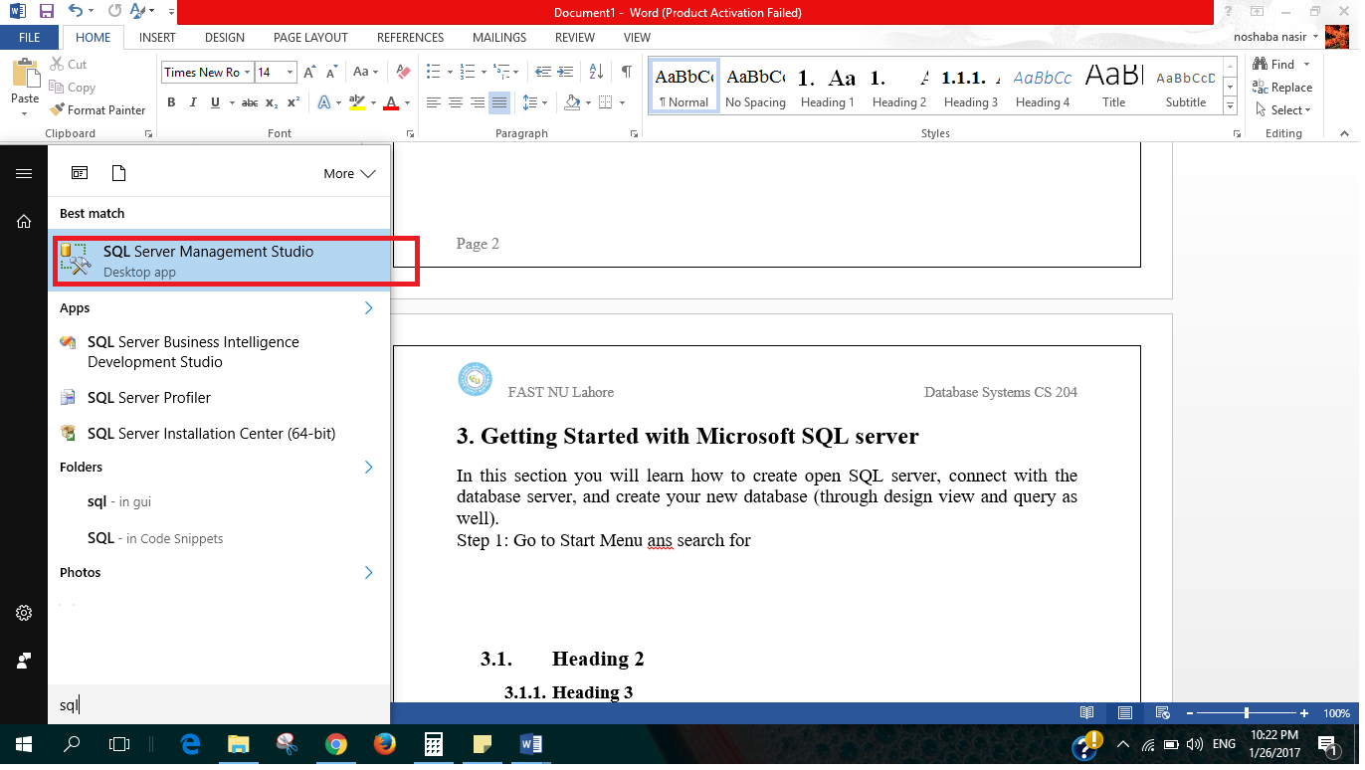

## Step 2: Connect to Server

One the left side you have object Explorer which you will use to explore all your databases and any object you create such as tables, on right there is Dynamic Help.

In the middle you can see Connect to server dialogue box.

Select SQL Server Authentication from Authentication Drop down

Ask for login and password from your lab instructor and press Connect

(refer to following figure)

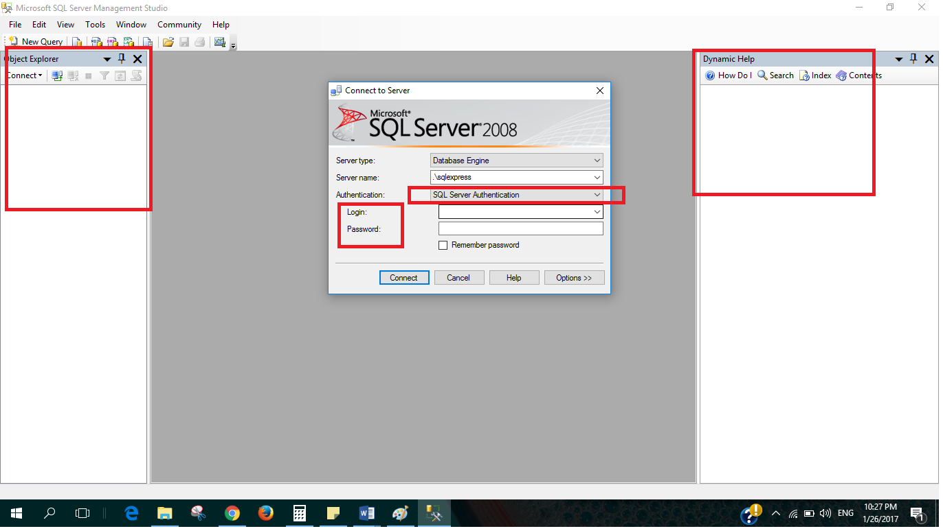

## Step 3: Create your own Database

There are two ways to create a new data base

* Through Query

>>Click on New Query, a new blank page will open (as shown in following figure)

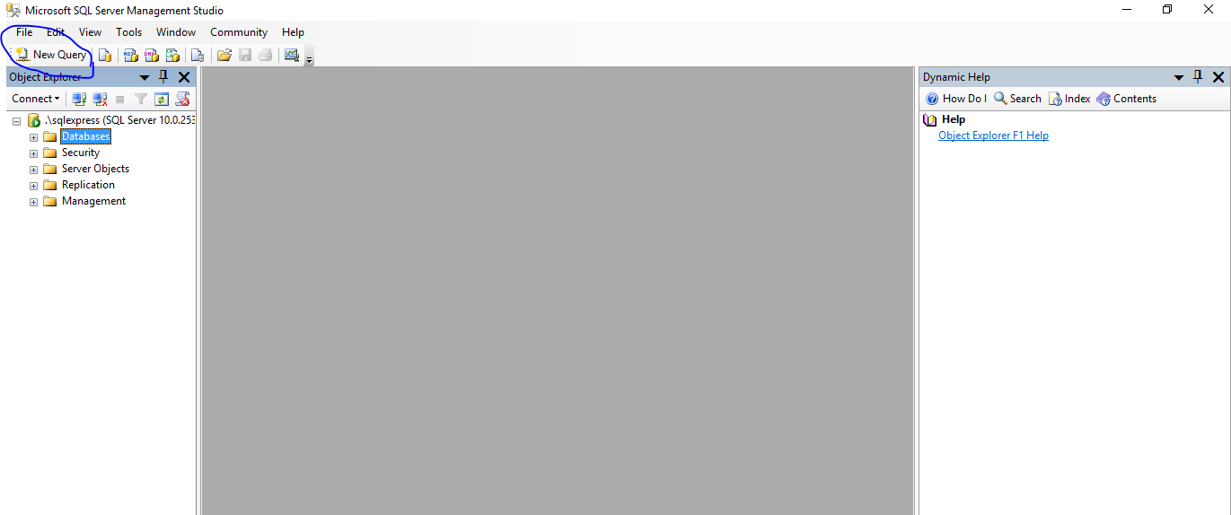

>>Write the following query on this page

create database <nameofyouDatabase>

>>Hit Execute button shown on top, Command completed successfully shows that you database has been created. (As shown in following figure)

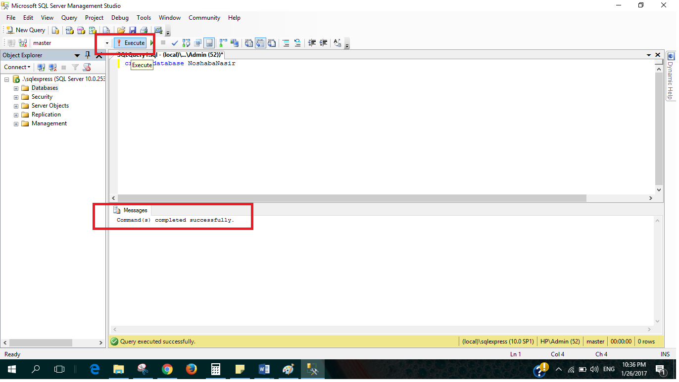

### >>If you want to delete your database write the following query and Execute, make sure that the command is executed successfully.

drop database <DatabaseName>

### You can also create new database by Left click on Database from object Explorer and select new Database, give it a name and press ok (as shown in following figures).

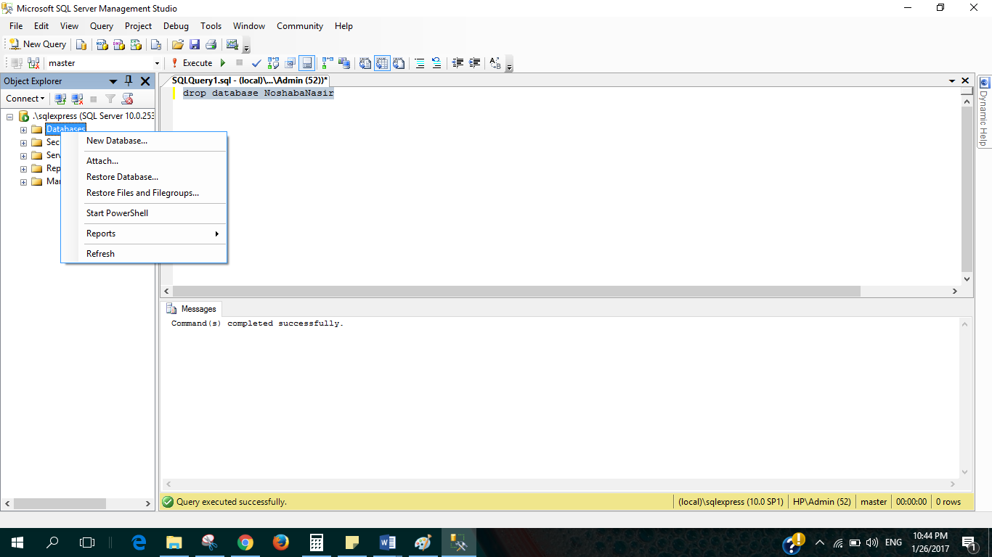

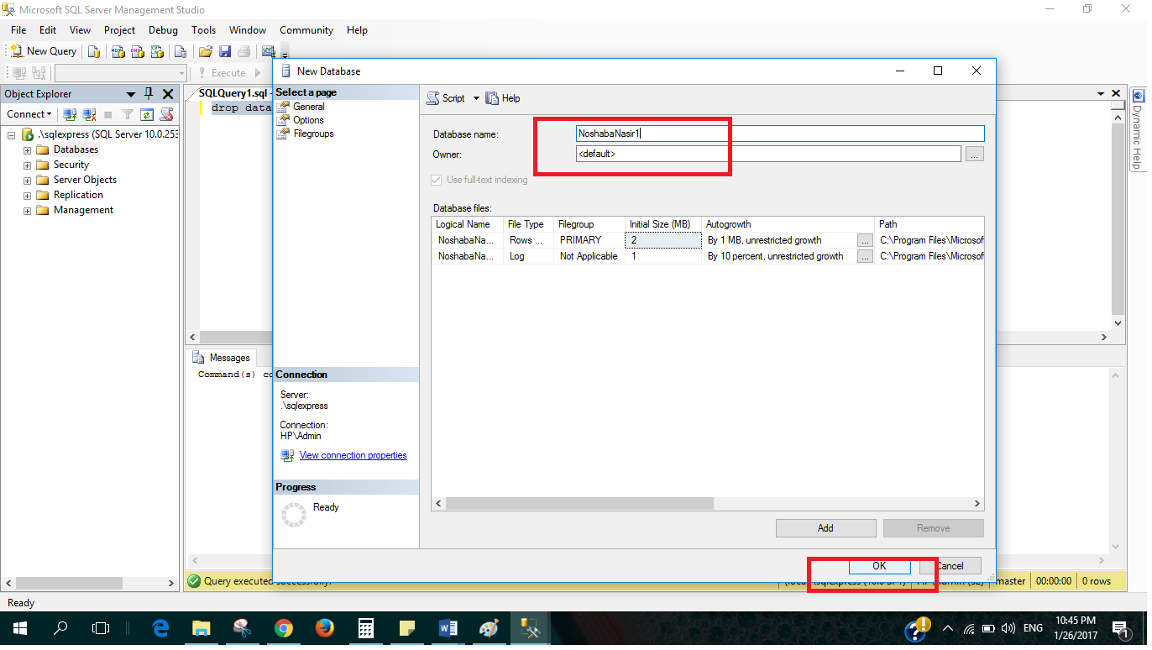

## Step 4: View and use your database

If you expand the Database from object explorer, you can see all of the databases that exist of the server, including the newly created ones (as shown in following figure).

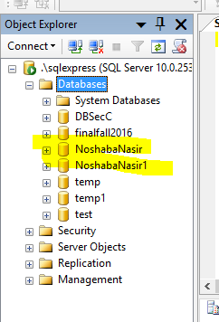

To use your database, make sure to select your database from drop down menu (as shown in following figure).

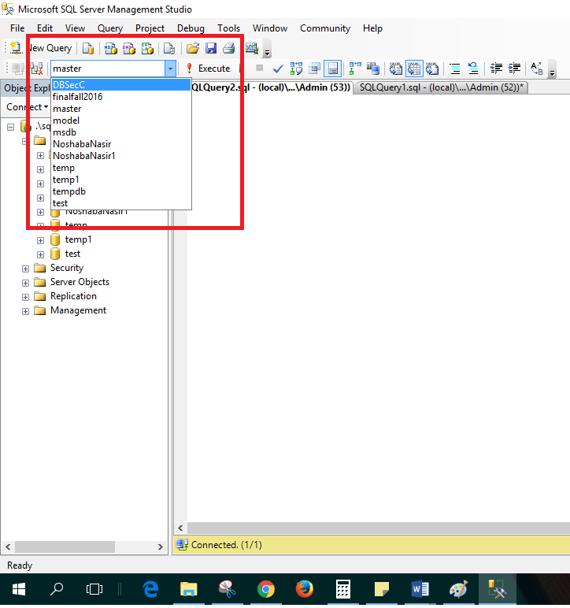

Or you can use the following query to use your database.

Use <databaseName>

# Data Definition Language:

Also called DDL includes creating objects such as tables, adding constraints of tables, such as FK PK unique constraints, in this section you will learn how to create tables and add PK, FK constraints using Queries.

## Step 1: Create table:

Following is the syntax of table creating query

create table [tablename]

(

[Column1Name] datatype null/Not null,

[Column2Name] datatype null/not null,

[Column2Name] datatype null/not null

)

\**null is default*

Create the table Students using the query as shown in following figure, Execute, make sure the message shows that the command is successful.

Go to object explorer and find you table.

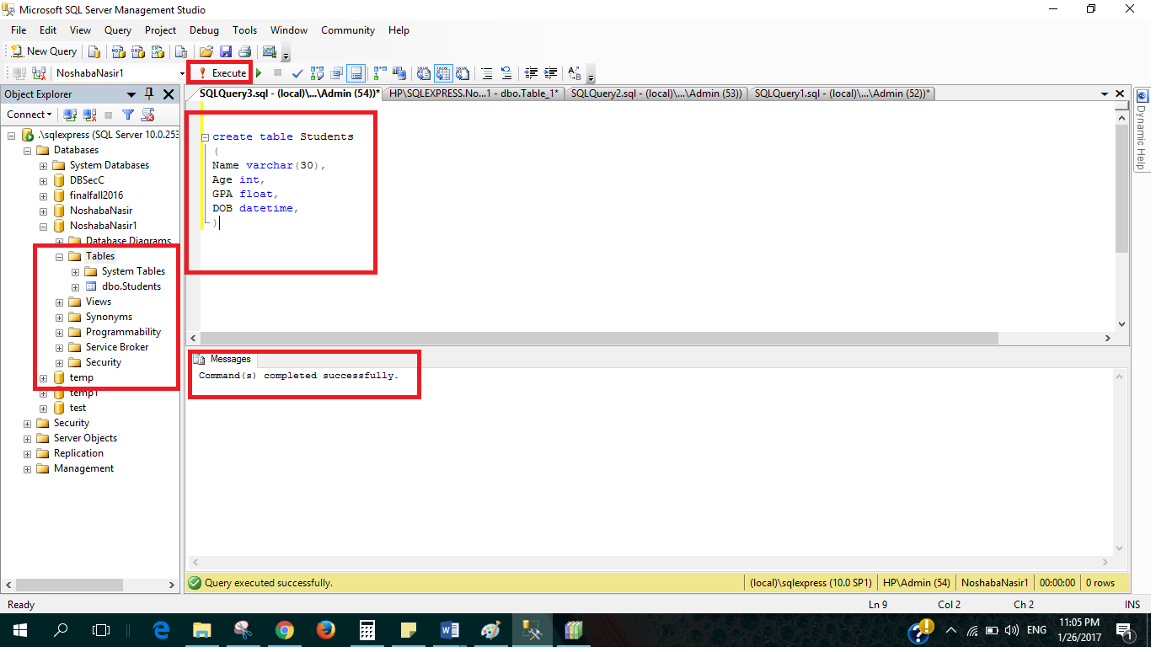

## Step 2: Altering table Schema

### Adding new column to existing table

alter table <TableName> add <NewColumn> <Datatype>

Try this query

alter table Students add Address varchar(50)

### Drop existing Column from existing table

alter table <TableName> drop column <ColumnName>

Try this query

alter table Students drop column [Address]

## Step 3: Add Primary key Constraint.

### One way to create Primary key is to add it whilst creating table using the following syntax

create table [tablename]

Try the following query, see in object explorer

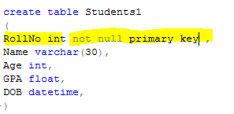

Primary key should be not null

(

[Column1Name] datatype primary key,

[Column2Name] datatype,

[Column2Name] datatype

)

OR if there is composite key

create table [tablename]

(

[Column1Name] datatype,

[Column2Name] datatype,

[Column2Name] datatype,

Primary key ([Column1Name], [Column2Name])

)

Try the following query, see in object explorer

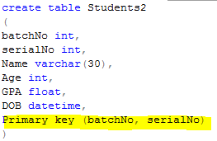

### Other way is to add Primary key constraint after creating the table, by using ALTER query,

alter table [tableName] add constraint [keyContraintName] Primary key (Column1, column2, column3)

Try the following, PK columns should be not null

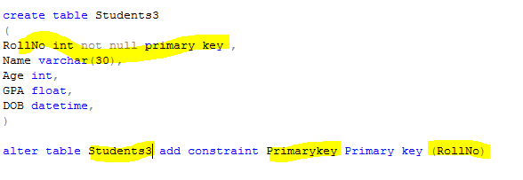

## How to see the schema of your table

Try this to see the schema of your table

sp_help <tableName>

This will give you information about colums, their datatype and all the constraints on the table.

## Step 4: Add foreign key constraint to tables

Before creating FK constraint Make sure that the referred table and its referred columns are created.

### Add FK whilst creating table.

Use the following syntax as given.

create table [tablename]

(

[Column1Name] datatype Null/Not Null,

[Column2Name] datatype Null/Not Null,

[ReferencingColumn] datatype Null/Not Null

FOREIGN KEY REFERNCES referedtable(referedColum)

ON DELETE NO ACTION/CASCADE/SET NULL/SET DEFAULT

ON UPDATE NO ACTION/CASCADE/SET NULL/SET DEFAULT

)

\**no action is default*

Try the following, and see in object explorer.

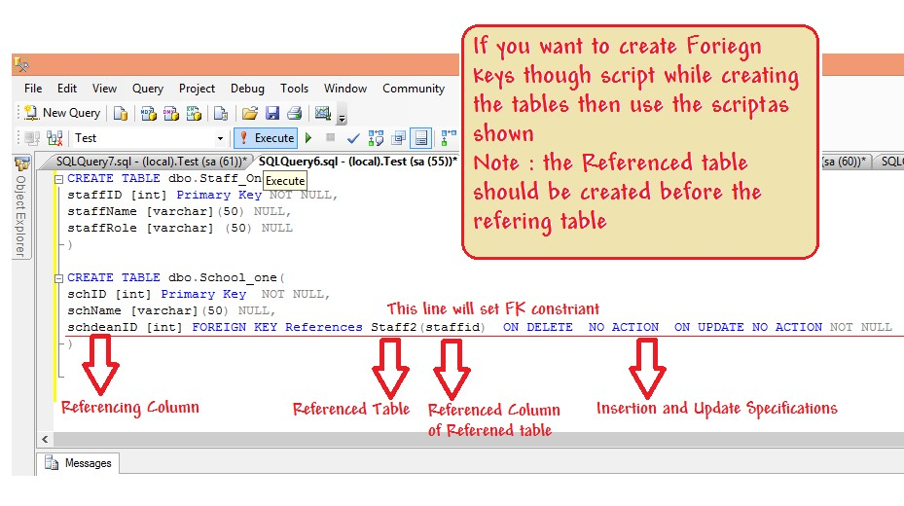

### FK can also be added after the referencing and referred tables have been created.

Try the following and see in object explorer

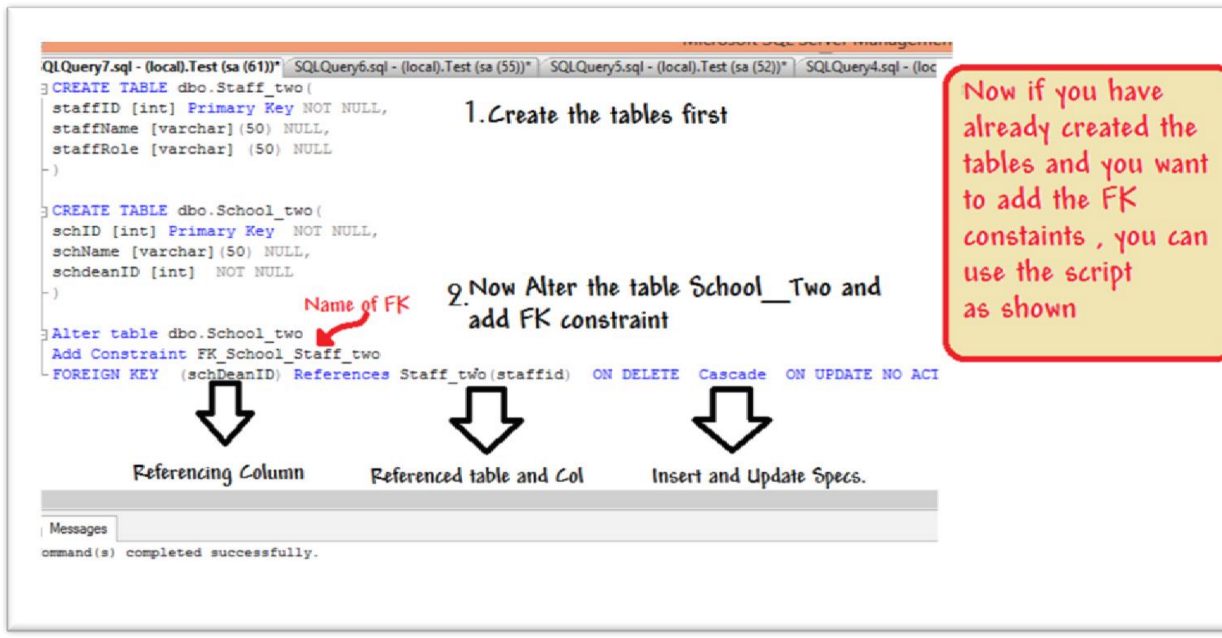

# Data Modification Language

## Step 1: Insert rows into table

Syntax

-- let there be N columns in a table

INSERT INTO <tableName>

values

(Column1Value,Column2Value, Column3Value,….,ColumnNValue), --row 1

(Column1Value,Column2Value, Column3Value,….,ColumnNValue), --row2

(Column1Value,Column2Value, Column3Value,….,ColumnNValue) –row 3

Or

INSERT INTO <tableName> (ColumnX,ColumnY) -- List of Columns

values

(ColumnXValue,ColumnYValue), --Row 1 list of Corrrespong column values

(ColumnXValue,ColumnYValue), --Row 2

(ColumnXValue,ColumnYValue) –Row 3

Try the following



Try the following



# Appendix

## Comments in SQL

Comments in SQL server start with two dashes as shown below, in green color

